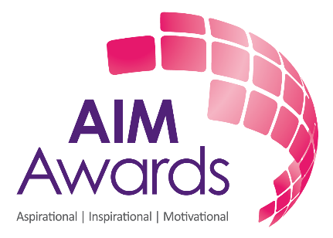
Product Description for Marketing
Counselling

Info for the marketing material for the new Centres
1 | Qualification name | AIM Awards Level 5 Diploma in Psychotherapeutic Counselling
2 | Internal release date | 19th December 2018
3 | Qualification description | The AIM Awards Level 5 Diploma in Psychotherapeutic Counselling provides opportunities for critical self-reflection and enables learners to work towards the production of a research proposal. The proposal will cover the field of counselling research and the methodological approaches to enquiry to assess and evaluate the practice of counselling and/or a topic relevant to the field.  Learners will embark on practice working within an ethical framework and will develop an understanding of the need for and value of supervision in counselling practice. Learners are also required to undertake research and develop a business plan required to establish, develop and maintain a private counselling practice.
4 | Is it new qualification? If no, how does it differ from the old one? | Revised and updated current qualification.
5 | Why this qualification is unique? (what is unique selling point) | The qualification is graded Pass, High Pass, Merit, High Merit and Distinction. (NEW)  This qualification is part of a suite available from Level 2 to Level 6 and are available for learners at different stages of their careers in counselling.  We also provide assignment briefs for all internally assessed assessments in this qualification (centres don’t need to design own assessment tasks). Where specified on the brief these may be contextualised by the centre, for example centres may choose to incorporate industry set scenarios.
6 | What skills can learners develop to be fit for the industry? | See point 3
7 | Why is it beneficial for centres to choose this Aim Awards qualification? | See point 5
8 | Who exactly is this qualification aimed at? | This qualification is aimed at learners whose qualification goal is to achieve professional status in counselling. It may also be appropriate for those working in roles where counselling skills are needed:  for example, nursing, teaching, social work, voluntary sector, the police and armed forces.  It is recommended that learners have achieved the AIM Awards Level 4 Diploma in Counselling Practice or equivalent before commencing this qualification. This will equip the learner with the prerequisite  level of knowledge, skills and understanding necessary to embark on a course at this level.  Learners will be expected to demonstrate a critical appreciation of theoretical concepts, legal and ethical issues in all their written work. At level 5, learners should be practitioners who have sufficient experience to evaluate how useful theoretical concepts are proving to be in their own client work.
9 | Any additional information | Complete re-design of current L5 qualification as never had any learners registered so wasn’t fit for purpose!
10 | Any additional information
If we have any photos purchased for this qualification, please attach them

