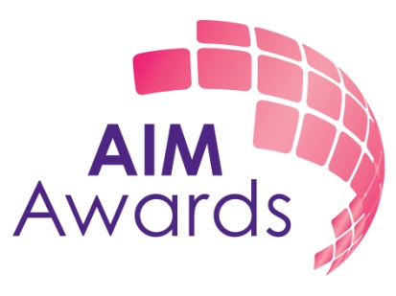

Information Pack

General Information About AIM Awards

How to Apply

Information about the role: End point assessment development lead

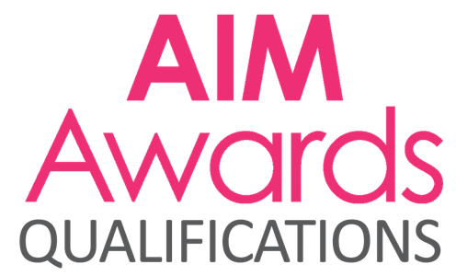 | 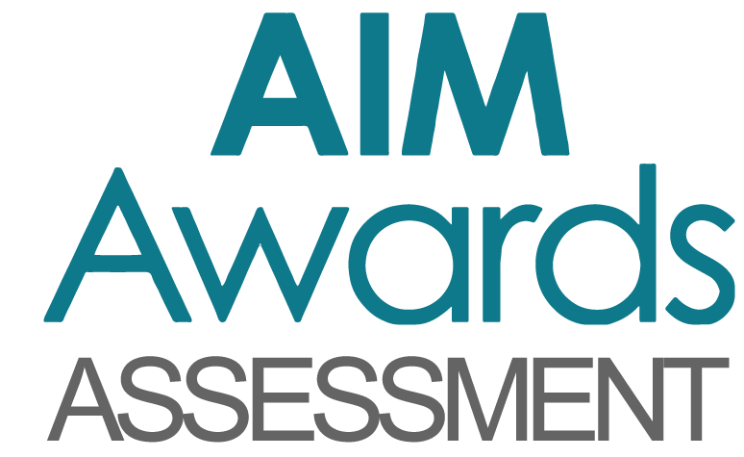 | 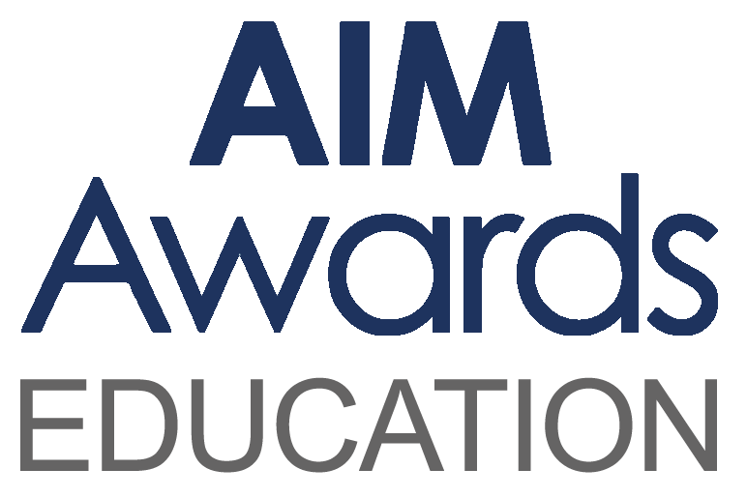

It’s what we do together that sets us apart –

Aspirational, Inspirational, Motivational

AIM Awards is a company Limited by Guarantee
Registered No. 5038056 Registered Charity No. 1103300

Dear Enquirer

Thank you very much for your interest in working at AIM Awards. We are a registered charity operating as an awarding organisation, Access to HE validating agency and end point assessment organisation. We have a head office based in Derby and are dedicated to offering a high quality, efficient and effective service whilst remaining supportive and accessible.

We want to continue to grow AIM Awards. We know that great businesses are powered by happy colleagues who feel invested in the company they work for. Our people are curious and creative colleagues that anchor us to our foundations and help achieve our charitable objectives for learning – all kinds of learning for all kinds of people. Whether it’s at home, in the classroom or in the workplace, learning is the key to improving our chances in life.

As well as providing a fun and inspiring workplace, over the years we have defined clear values that inform everything we do, ensuring all our teams are striving to be world class, constantly innovating and inspiring positivity in their colleagues.

Not just co-workers, we're proud AIM Awards colleagues who help our company thrive. Our friendly and professional teams work together in a diverse range of roles to support the future of work and learning around the world. If you share our commercial focus and passion for helping people to realise their potential – discover more about the exciting careers and great benefits we can offer you.

Key information:
- We have a portfolio of over 500 regulated qualifications in a range of subject areas
- We work in over 40 countries through our partnership with Anglia Examinations
- We validate the Access to HE Diploma for a wide range of FE colleges and training providers
- We are building a series of online training courses to support delivery of our qualifications
- We are developing our footprint as the end point assessment organisation of choice for the creative industries
- We have 42 full and part time staff in addition to a large number of subcontracted verifiers, assessors and examiners

I place tremendous personal importance on getting the right person to maintain the excellent levels of customer service in which we pride ourselves.
I look forward to your application.

Linda Wyatt
Chief Executive

We welcome applications from all sectors and communities and are able to make specific arrangements and adjustments for candidates whose circumstances require this.
Background

AIM Awards is an Awarding Organisation regulated by Ofqual, CCEA and Qualifications Wales to develop, deliver and award qualifications. We are also recognised by the Quality Assurance Agency for Higher Education (QAA) as an Access Validating Agency (AVA) to develop and approve courses leading to entry to Higher Education. We are currently approved by the ESFA to develop end point assessment for six apprenticeship standards in the creative industries and have an ambitious development plan for significant growth in this new market.
We are a registered charity and originated as an organisation in the 1980’s, becoming AIM Awards in 2011. In the past few years we have expanded internationally with our ESOL provision and are now working in partnership with Anglia Examinations in 43+ countries.

We work closely with Employers, Further Education colleges, Higher Education institutions, Schools, Offender Learning centres, Voluntary and Community Sector organisations and Private Training Providers to ensure our products are as good as they can be. Our qualifications are used by over 400 recognised centres and a growing number of employers and training providers are turning to us for end point assessment.

Our strategic aims are to:
- Be established as a significant high quality end point assessment organisation
- Be a leading high quality AVA
- Grow our international market
- Be a major provider of offender learning
- Maintain and grow all our brands and markets
- Maintain compliance with all regulators

About the role

End point assessment development lead
Salary range: £28,578-£31,236
37 hours per week, Flexible working
Location: Home or office based (Derby, AIM Awards head office)
This role represents an exciting opportunity to join a successful awarding organisation and end point assessment organisation. AIM Awards have a portfolio of over 500 regulated qualifications and in the last two years have become recognised as the end point assessment of choice for the creative industries. We have six standards in operation and ambitious growth plans.

We believe in the positive power of education
We want to keep AIM Awards going and growing. We know that great businesses are powered by happy colleagues who feel invested in the company they work for. Our people are curious and creative colleagues that anchor us to our foundations and help to achieve our charitable objectives for learning – all kinds of learning for all kinds of people. Whether it’s at home, in the classroom or in the workplace, learning is the key to improving our chances in life.

As well as providing a fun and inspiring workplace, over the years we have defined clear values that inform everything we do, ensuring all our teams are striving to be world class, constantly innovating and inspiring positivity in their colleagues.

Not just co-workers, we're proud AIM Awards colleagues who help our company thrive. Our friendly and professional teams work together in a diverse range of roles to support the future of work and learning around the world.

We are currently recruiting for two new positions to support our growth in end point assessment in the role of end point assessment development lead.

OVERALL JOB PURPOSE

The EPA development lead is an exciting opportunity for the right candidate to lead the development, implementation and evaluation of the AIM assessment portfolio, from consultation and design to development and delivery, following up with review and evaluation of our EPA products to ensure validity and that they are fit for purpose.

The EPA development lead will work closely with the director of product integrity, the EPA delivery manager, lead assessor and employers to provide a sector leading portfolio of assessments. The ideal candidate should be a strong communicator and team player with the ability to build strong working relationships in order to liaise with employers, occupational experts and relevant organisations throughout the development process.

The ideal candidate will be able to provide extensive specialist knowledge of assessment, knowledge of assessment practice, methodology and development of assessment material. They should have demonstrable experience of writing, delivering and evaluating assessments and/or examinations.

The ideal candidate will have experience of teaching in a relevant occupational area (content production, VFX, marketing, PR, advertising) and an understanding of cross sector post 16 education. They will have an in depth understanding of vocational assessment and delivery.

Project management is key within this role. The ideal candidate should have experience in delivering a project from its inception to completion in order to support our future aspirations. They should value accuracy and efficiency in their work, with the ability to be consistent in delivering attention to detail. Time management is essential within this role, as is flexibility with hours and tasks to meet business needs. To support this, AIM awards are offering flexible working and the ability to work from home for this role.

Minimum requirements are:
- Extensive knowledge of assessment practices
- Experience of writing, delivering and evaluating assessments and examinations
- Experience of teaching in a relevant occupational area
- An understanding of cross sector post 16 education
- In depth understanding of vocational education, assessment and delivery
- Knowledge of the current marketplace for assessments
- Demonstrable experience in project management, showing strong organisation and prioritisation skills with successful delivery outcomes
- Strong communication skills, both written and oral
- Demonstrable ability to deliver a high level of accuracy within their work
- Flexible approach to work, this role may require some travel

How to apply

An application pack can be downloaded from our website www.aimawards.org.uk or contact Rachael Tweddle on Tel: 01332 341822 Email: Rachael.Tweddle@aimawards.org.uk or write to AIM Awards, 3 Pride Point Drive, Pride Park Derby, DE24 8BX.

Closing date for applications is Friday 26th July 2019.

Interview and selection process
All candidates will be required to complete a role related skills assessment as part of the interview process.
AIM Awards is a company Limited by Guarantee
Registered No. 5038056 Registered Charity No. 1103300

