JOB DESCRIPTION |  | 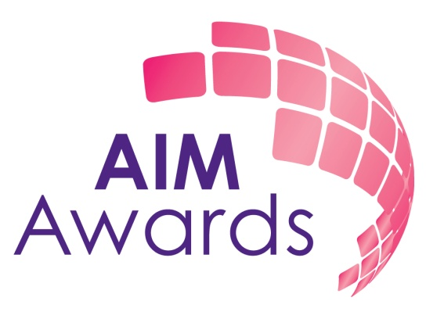
JOB TITLE | Qualification Developer – 3 month Project

JOB HOLDERS NAME

HOURS PER WEEK |  | LOCATION | AIM Awards Office or Home Based

KEY RELATIONSHIPS

Internal
- Director of Quality and Operations
- Director of Business and Brand Development
- Project Development Officer
External
- Providers
- Curriculum Experts
- Regulators
REPORTS TO
- Director of Assessment and Qualifications
OVERALL JOB PURPOSE

- To manage the development of new qualification suites

KEY RESULT AREAS

1. Qualification Development

1.1 Lead the development of qualifications, assessments and resources within the Ofqual guidelines to meet defined customer need regionally, nationally or internationally
1.2 Ensure that an accurate audit trail of the development process is maintained.
1.3 Liaise with appropriate organisations and regulatory bodies in the development and accreditation of qualifications
1.5 Ensure that equality and diversity and the needs of particular learner groups are addressed in the development process.
1.6 Write and review units in accordance with AIM Awards and regulator guidelines
1.7 Prepare and review submissions for approvals panels
1.8 Check documentation for other qualification developments prior to submission for approval
1.9 Carry out qualification reviews as part of the reaccreditation process
2. General

2.1 Have due regard to matters of Health and Safety in the workplace and abide by the spirit and intention of AIM Award’s Equal Opportunities Statement at all times.

2.2 Undertake any other duties as appropriate to the post as requested by the Board of AIM Awards.

3. COMPETENCIES (skills, knowledge, experience, required behaviours)

  - Communication Skills (written and oral)
  - Eye for detail
  - Initiative
  - Team work
  - Time management

4. ADDITIONAL SELECTION CRITERIA

Essential:
- Knowledge of qualification development and the Ofqual processes for qualification accreditation
- Knowledge of the Adult Education and/or Schools sector

Desirable:
- Experience of qualification development
- Experience of project management
- Clean driving licence

AIM Awards reserves the right to review and amend the content and reporting lines of this contract.

