AIM Awards
Level 1 Award Health and Safety in a Construction Environment (QCF) V1

Assessment Resource Pack
Learner Name:
Learner Number:
Course:
Tutor:
Learner Signature:
Date Started:
Date Completed:

About this Qualification
This qualification will enable you to understand the principles of risk assessment, safe manual handling, working at height and using equipment as well as the general health risks in a construction environment.

Tutor Notes:
It is recommended that this assessment pack is applied to a specific context/job role in the construction industry. The Tutor must identify a scenario for the assessment tasks and this must be carried through all the tasks in the document.
The assessment tasks should be approved by the Internal Verifier for the course before delivery takes place in order to ensure the assessment is fit for purpose and meets the standards required.

Using this assessment pack
As you work through this pack, you will find exercises to complete as you learn about Health and Safety requirements in a practical environment. The exercises will support your learning and so it is expected that you will complete all of them and have them marked. The completed, marked exercises are the assessments on which your achievement of the AIM Awards Level 1 Award in Health and Safety in a Construction Environment (QCF) is based.

Tracking your evidence
During your course, your Tutor/Assessor will ask you to carry out work either in the classroom, or at home which you’ll keep as evidence of your learning.

The work you produce (evidence) will be assessed by your Tutor/Assessor to make sure you have covered everything in sufficient detail. Your evidence could be made from a combination of:

• Written work or class notes
• Products or samples of practical work
• Case studies
• Learning logs
• Video or audio recordings
• Other appropriate formats suggested by your Tutor/Assessor

When all of your evidence is gathered together in a file or folder, this will become your portfolio.

Your centre and Assessor may have systems that they use to plan and monitor your assessment. These may be computer-based (e.g. using ‘e-portfolio’ software) or paper-based (using forms or checklists). These systems are designed to show how each piece of evidence meets the learning outcomes and assessment criteria.

You will be working to achieve the following learning outcomes:
Health and Safety in a Construction Environment L1

- Know the principles of risk assessment for maintaining and improving health and safety at work
- Know the importance of safe manual handling in the workplace
- Know the importance of working safely at height in the workplace
- Know risks to health within a construction environment
- Know the importance of working around plant and equipment safely

Record of Learner Achievement
Learning Outcomes  The learner will: | Assessment Criteria  The learner can: | Evidence Location | Completed?  (Learner Tick)
- Know the principles of risk assessment for maintaining and improving health and safety at work | - State the purpose of risk assessments and method statements  - State the legal requirements of risk assessments and method statements  - State common causes of work-related:  - fatalities  - injuries  - State the implications of not preventing accidents and ill health at work  - State the meaning of the following in relation to health and safety at work:  - accident  - near miss  - hazard  - risk  - competence  - List typical hazards/risks associated with the following:  - resources  - equipment  - obstructions  - storage  - services  - wastes  - work activities  - State the importance of reporting accidents and near misses  - State typical accident reporting procedures  - State who is responsible for making accident reports | 9
 |  | 9
 |  | 11
 |  | 11
 |  | 11
 |  | 12
 |  | 12
 |  | 12
 |  | 12
 |  | 12
 |  | 13
 |  | 13
 |  | 13
 |  | 13
 |  | 13
 |  | 13
 |  | 13
 |  | 14
 |  | 14
 |  | 14
- Know the importance of safe manual handling in the workplace | - State the reasons for ensuring safe manual handling in the workplace  - State potential injuries and ill health that may occur from incorrect manual handling  - State the employee’s responsibilities under current legislation and official guidance for:  - moving and storing materials  - manual handling  - mechanical lifting  - State the procedures for safe lifting in accordance with official guidance  - State the importance of using site safety equipment when handling materials and equipment  - List aids available to assist manual handling in the workplace  - State how to apply safe work practices, follow procedures and report problems when carrying out safe manual handling in the workplace | 15
 |  | 15
 |  | 16
 |  | 16
 |  | 16
 |  | 17
 |  | 17
 |  | 18
 |  | 18
- Know the importance of working safely at height in the workplace | - Define the term ‘working at height’  - State the employee’s responsibilities under current legislation and official guidance whilst working at height  - List hazards/risks associated with the following:  - dropping tools and debris  - stability of ladders  - overhead cables  - fragile roofs  - scaffolds  - internal voids  - equipment  - the working area  - other people  - State how hazards/risks associated with working at height can be controlled  - State the regulation that controls the use of suitable equipment for working at height | 19
 |  | 16
 |  | 13
 |  | 13
 |  | 13
 |  | 13
 |  | 13
 |  | 13
 |  | 13
 |  | 13
 |  | 14
 |  | 19
 |  | 20
- Know risks to health within a construction environment | - List substances hazardous to health under current regulations  - List common risks to health within a construction environment  - State the types of hazards/risks that may occur in the workplace linked with use of drugs and alcohol  - State the importance of the correct storage of combustibles and chemicals on site  - State the importance of personal hygiene within a construction environment  - State the potential hazards/risks to the health of workers exposed to asbestos  - State types of asbestos waste  - State types of personal protective equipment (PPE) used when dealing with hazardous materials | 21
 |  | 21
 |  | 22
 |  | 22
 |  | 23
 |  | 23
 |  | 24
 |  | 24
- Know the importance of working around plant and equipment safely | - List ways in which moving machinery can cause injuries  - State hazards/risks relating to the use of plant and equipment  - State the importance of keeping a safe distance away from plant/machinery and equipment until clear contact is made with the operator  - Outline how method statements can assist in ensuring the safety of workers where moving plant is in use  - State ways to eliminate or control hazards/risks relating to working around plant and equipment  - Identify hazard warning signs and symbols used around the use of plant and equipment | 25
 |  | 25
 |  | 26
 |  | 10
 |  | 26
 |  | 27

Assessment Guidance
Learning Outcome 1
1.6 Typical hazards/risks: at least one hazard/risk must be listed for each of the sub-criteria: resources, equipment, obstructions, storage, services, wastes, work activities.

Learning Outcome 2
2.6 Aids: at least four aids must be listed.

Learning Outcome 3
3.3 Hazards/risks: at least one hazard/risk must be listed for each of the sub-criteria: dropping tools and debris, stability of ladders, overhead cables, fragile roofs, scaffolds, internal voids, equipment, the working area, other people.

Learning Outcome 4
4.7 Types of asbestos waste: at least two types must be stated.
4.8 Types of personal protective equipment: at least three types must be stated.

Learning Outcome 5
5.2 Hazards/risks: at least five must be stated.

Final Tutor Feedback (Strengths and Areas for Improvement):

Learner Submission Disclaimer
I declare that this is an original piece of work and that all of the work is my own unless referenced.

Assessor Disclaimer
I confirm that this learner’s work fully meets all the assessment criteria listed above at the correct level and that any specified evidence requirements have been addressed.

Assessor |  | Learner |  | Date

Expectations
Complete this section before you start the course.
One expectation you have of the course:

…………………………………………………………………………………………………………………………………………………….………………
…………………………………………………………………………………………………………………………………….………………………………
…………………………………………………………………………………………………………………….

One thing you would like to get out of the course:
…………………………………………………………………………………………………………………………………………………….………………
………………………………………..………………………………………………………………………………………….…………………………………
………………………………………………………………………………………………………………….
Please keep hold of this sheet. It can be useful to look at it later and see how it compares with how you found the course at the end.

Review
Complete this at the end of the course.
One thing you have learned from the course:

…………………………………………………………………………………………………………………………………………………….………………
………………………………………..………………………………………………………………………………………….…………………………………
………………………………………………………………………………………………………………….

One thing you can take with you for the future:
…………………………………………………………………………………………………………………………………………………….………………
………………………………………..………………………………………………………………………………………….…………………………………
………………………………………………………………………………………………………………….

Health and Safety in a Construction Environment
Outline the scenario you are going to use for your assessment tasks below:

LO1. Know the principles of risk assessment for maintaining and improving health and safety at work
LO3. Know the importance of working safely at height in the workplace
LO5. Know the importance of working around plant and equipment safely

  - & 1.2 State the purpose and the legal requirements of risk assessments
  - & 1.2 State the purpose and the legal requirements of method statements

In the table below, state the purpose and legal requirements of risk assessments:
Purpose:

Legal requirements:

In the table below, state the purpose and legal requirements of method statements:
Purpose:

Legal requirements:

5.4. Outline how method statements can assist in ensuring the safety of workers where moving plant is in

5.4. Outline how method statements can assist in ensuring the safety of workers where moving plant is in use
Outline how method statements can assist in ensuring the safety of workers where moving plant is in use:

1.3. State common causes of work related a) fatalities b) injuries:
Complete the table below with common causes of work related fatalities and injuries:
Fatalities | Injuries

1.4. State the implications of not preventing accidents and ill health at work
State what could happen as a result of not preventing accidents and ill health at work:

1.5. State the meaning of the following terms in relation to health and safety at work

Complete the table below:

What is the meaning of the term in relation to health and safety at work?
accident

near miss

hazard

risk

competence

1.6. & 3.3 List typical hazards/risks associated with each of the following
Complete the table below with typical hazards and risks associated with each of the following:

Hazard/ Risk
resources
equipment
obstructions
storage
services
wastes
work activities
dropping tools and debris
stability of ladders
overhead cables
fragile roofs
scaffolds
internal voids
equipment
the working area
other people

1.7 State the importance of reporting accidents and near misses
1.8 State typical accident reporting procedures
1.9 State who is responsible for making accident reports

Complete the questions below:

 | Who is responsible for making accident reports at work?
What are the typical accident reporting procedures? |  | Why is it important to report accidents and near misses?

LO2. Know the importance of safe manual handling in the workplace
LO3. Know the importance of working safely at height in the workplace
2.1. State the reasons for ensuring safe manual handling in the workplace
2.2. State potential injuries and ill health that may occur from incorrect manual handling

State the reasons for ensuring safe manual handling in the workplace below:

State the potential injuries and ill health that may occur from incorrect manual handling below:

2.3 State the employee’s responsibilities under current legislation and official guidance for (a) moving and storing materials (b) manual handling (c) mechanical lifting
3.2 State the employee’s responsibilities under currently legislation and official guidance whilst working at height

Complete the table below with your responsibilities:

Employee’s responsibilities
Moving and storing materials
Manual handling
Mechanical lifting
Working at height

2.4. State the procedures for safe lifting in accordance with official guidance
State the procedures for safe lifting in accordance with official guidance:

2.5. State the importance of using site safety equipment when handling materials and equipment
Why is it important to use site safety equipment when handling materials and equipment?

2.6. List aids available to assist manual handling in the workplace
List four aids available to assist manual handling in the workplace:
1. | 2.

3. | 4.

2.7. State how to apply safe work practices, follow procedures and report problems when carrying out safe manual handling in the workplace

When carrying out safe manual handling in the workplace, state how to:

Apply safe work practices | Follow procedures | Report problems

3.1. Define the term ‘working at height’
Define the term ‘working at height’ below:

3.4 State how hazards /risks associated with working at height can be controlled
How can hazards/risks associated with working at height be controlled?

3.5. State the regulation that controls the use of suitable equipment for working at height
State the regulation that controls the use of suitable equipment for working at height:

LO4. Know risks to health within a construction environment
4.1. List substances hazardous to health under current regulations
List examples of substances hazardous to health under current regulations:

4.2. List common risks to health within a construction environment
List common risks to health within a construction environment:

4.3. State the types of hazards/risks that may occur in the workplace linked with use of drugs and alcohol
State the types of hazards or risks that may occur in the workplace linked with the use of drugs and alcohol:

4.4 State the importance of the correct storage of combustibles and chemicals on sight
Why is it important to correctly store combustibles and chemicals on site?

4.5. State the importance of personal hygiene within a construction environment
Why is personal hygiene important within a construction environment?

4.6. State the potential hazards/risks to the health of workers exposed to asbestos
What are the potential hazards/risks to the health of workers exposed to asbestos?

4.7. State types of asbestos waste
State two types of asbestos waste below:
4.8. State types of personal protective equipment (PPE) used when dealing with hazardous materials
Using the images below, label three types of personal protective equipment (PPE):

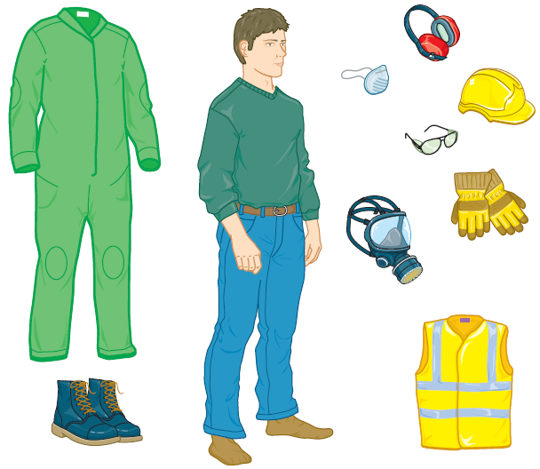

LO5 Know the importance of working around plant and equipment safely
5.1 List ways in which moving machinery can cause injuries
List ways in which moving machinery can cause injuries:

5.2 State hazards/risks relating to the use of plant and equipment
State at least 5 hazards/risks relating to the use of plant and equipment:

5.3 State the importance of keeping a safe distance away from plant/machinery and equipment until clear contact is made with the operator
Why is it important to keep a safe distance away from plant/machinery and equipment until clear contact is made with the operator?

5.5 State ways to eliminate or control hazards/risks relating to working around plant and equipment
Complete the table below with possible hazards/risks relating to working around plant and equipment, and ways to eliminate or control these:

Hazards/risks | Ways to eliminate/control

5.6 Identify hazard warning signs and symbols used around the use of plant and equipment
Complete the table below with meanings of each hazard warning sign and symbols:

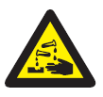 |  | 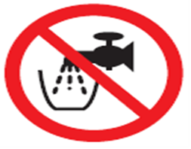
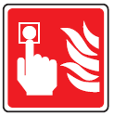 | 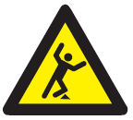 | 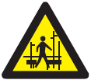
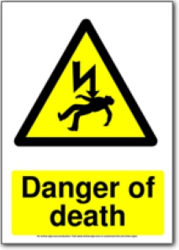 | 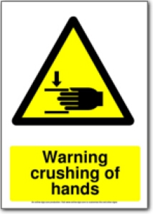 | 